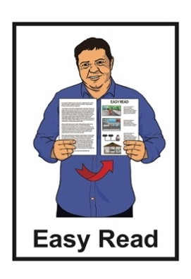
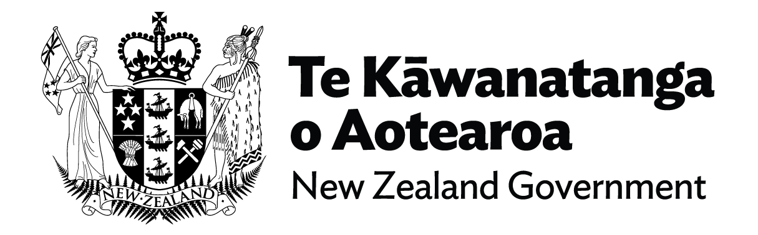

Information about the
New Zealand Traveller Declaration form
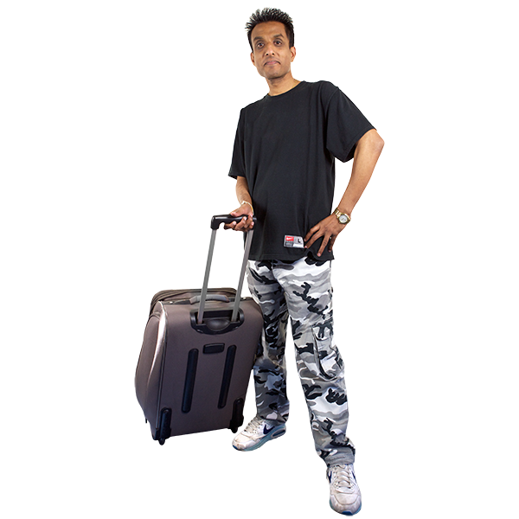
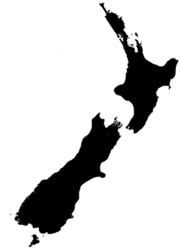

Updated: October 2023

What you will find in this document

Page number:

Before you read this.……………….3

What is this document about?.........4

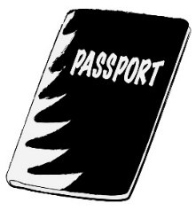
What you need to fill in your
NZTD ..7

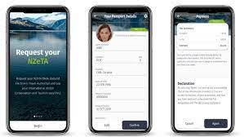
When you can submit your
NZTD 15

Making changes to your
declaration 19

Page number:
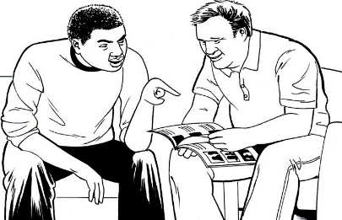

When you arrive in New Zealand...21

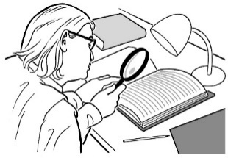
Checklist for travelling to
New Zealand 23

How to contact us 24

Before you read this
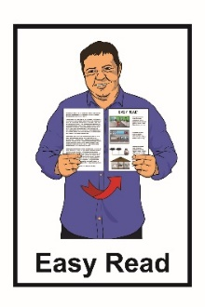
This is a long document.
While it is written in Easy Read it can be hard for some people to read a document this long.

Some things you can do to make it easier are:
read a few pages at a time
- have someone support you to understand it.

What is this document about?

This Easy Read document is about the New Zealand Traveller Declaration.
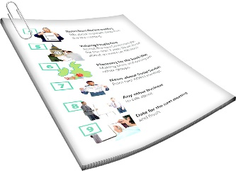
The New Zealand Traveller Declaration is also called the NZTD.

A NZTD needs to be completed for everyone who comes to New Zealand.

The NZTD is a form that tells Immigration New Zealand where you have been while outside New Zealand.

People arriving in New Zealand by plane need to fill in a NZTD.

The NZTD helps to keep our:
tangata / people safe
whenua / land safe.
You can do a digital declaration.

A digital declaration is a form you fill in online.
You can fill in the form on the NZTD website at:

travellerdeclaration.govt.nz

You can also download the NZTD app.
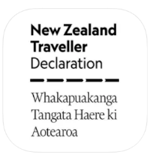
An app is a program you can
download to your phone or tablet.

The app lets you do the same things as the NZTD website.

What you need to fill in your NZTD
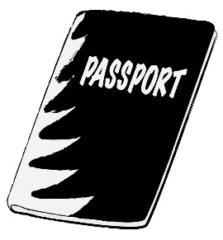
To fill in your NZTD you need to have:
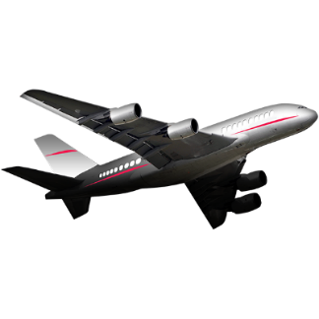
your passport
information about your flight to New Zealand
your contact information like mobile phone number
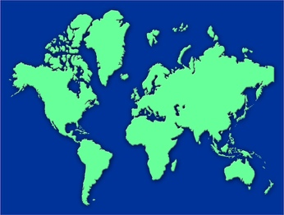
information about where you have travelled in the last few months
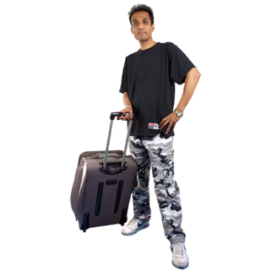
information about what you are bringing into New Zealand.

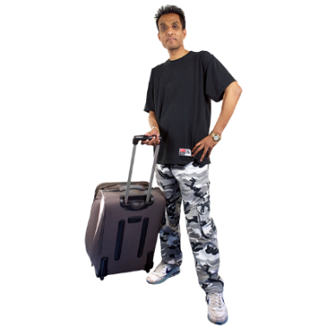
You can find information about what you can and cannot bring into New Zealand on these websites:
www.mpi.govt.nz/CanIBringIt
www.customs.govt.nz/PRI-traveller
These websites are not in Easy Read.

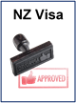
To fill in your NZTD you will also need:

your immigration status which says whether you:

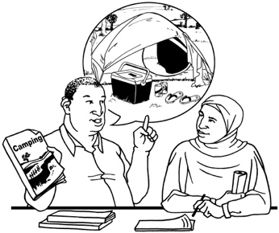
- are a citizen of New Zealand or Australia

- are a permanent resident of New Zealand or Australia

- or need a visa to enter New Zealand

your visa information if that applies to you.

Immigration status means what kind of permission you have to be in a country.

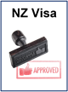
A visa is official permission to come to / stay in a country.

A visa can be a stamp on your passport or an electronic record if you have an e-passport.
To fill in your NZTD you may also need a New Zealand Electronic Travel Authority.

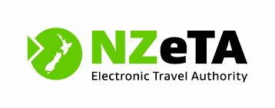
A New Zealand Electronic Travel Authority lets you travel to New Zealand if you do not have a visa.

It is also called a NZeTA.
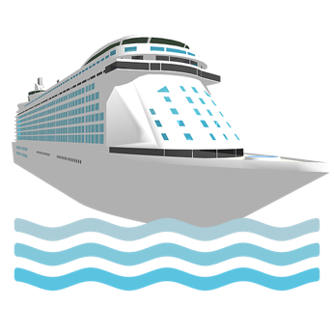

People who need a NZeTA include:
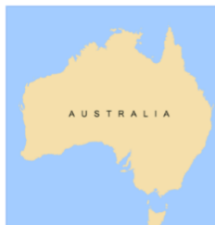
people from a visa waiver country
cruise ship passengers
permanent residents of Australia.

If you are from a visa waiver country you may be able to visit New Zealand without a visa.

You will need to prove that you:
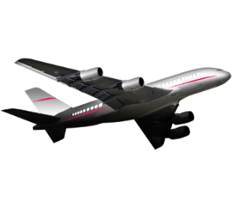
- can fund your stay
- have travel booked to leave New Zealand.

You can find more information about visa waivers at this website:

www.immigration.govt.nz/new-zealand-visas/visas/visa/visa-waiver
The information on this website is not in Easy Read.

To enter New Zealand you must:
hold a valid visa
or
be travelling on a passport from a visa waiver country.
If you are from a visa waiver country, you will need a NZeTA before you travel.

If you are travelling on an Australian passport you do not need an NZeTA.
You can find out more about visa waiver countries and NZeTA at this website:
immigration.govt.nz/new-zealand-visas
It is okay to get someone to help you fill in your NZTD.

You can fill in a paper NZTD form when you get to New Zealand.
A separate NZTD form must be completed for each person.
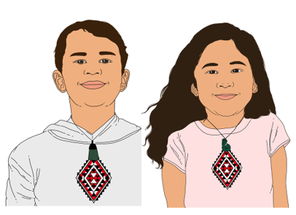

A NZTD form must also be completed for:
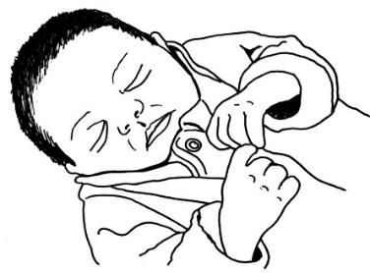
children
infants / babies.

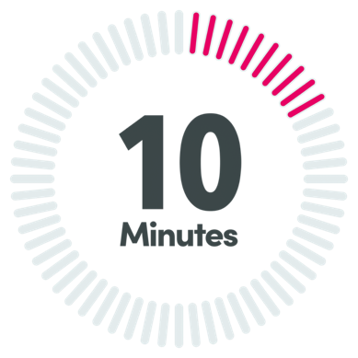
The NZTD is free to complete.

It will take about 10 minutes to complete.

When you can submit your NZTD

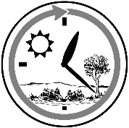
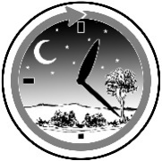
The earliest you can submit your NZTD is 24 hours before you start your trip to New Zealand.
24 hours is as long as 1 day and 1 night.

You can update your NZTD right up until you reach passport control in New Zealand.
Passport control is where your passport gets checked before you are allowed into New Zealand.

After you submit your NZTD you will get an email telling you what you need to know when you enter New Zealand.
You do not need to add any documents to your NZTD or print it out.

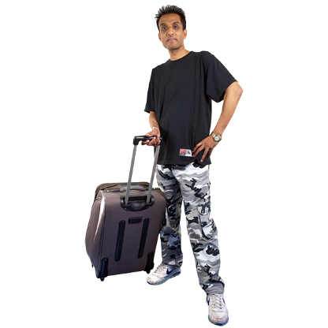
Some goods / things cannot be brought into New Zealand.
These are things like:
food
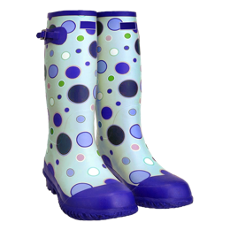
outdoor equipment with dirt on it
animal products like cheese
plant products like fruit.
These things may carry:
harmful pests like insects
diseases that could make people sick.

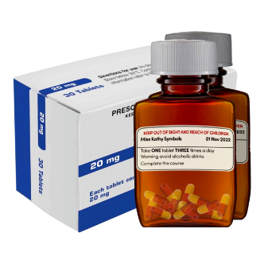
You may need to declare / say that you have:
medicines
cigarettes
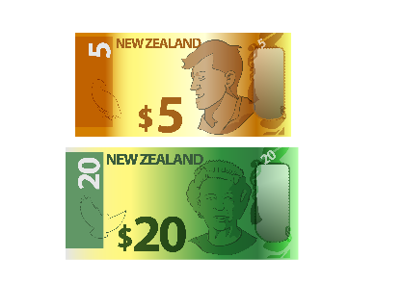
alcohol like beer or wine
cash over NZ 10 thousand dollars.

Making changes to your declaration

When you start your online declaration, you will be emailed a reference number.

Your reference number can be used to:
check your declaration
complete your declaration
make changes to your declaration.

If you make any changes to your NZTD you will need to submit it again.

You cannot make any changes to your declaration after you have gone through passport control in New Zealand.

If you have forgotten to declare something you will need to talk to a border officer.

A border officer is a person who decides if you can enter the country or not.

You may have to ask to see a border officer.

When you arrive in New Zealand

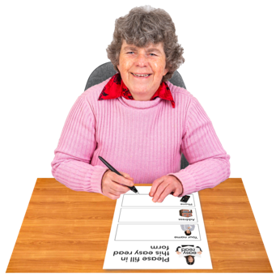
When you arrive in New Zealand you may have to fill in a paper declaration form.
If you fill in a digital NZTD online you do not need to fill in a paper NZTD form.

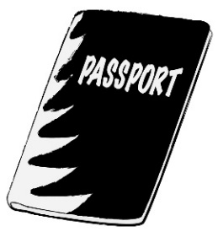
Your NZTD will be checked:
when you scan your passport at the eGate
by a border officer on arrival into New Zealand.

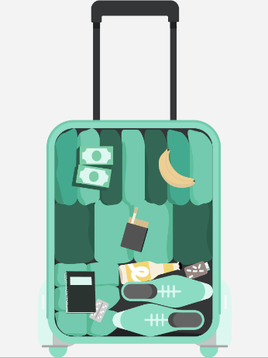
Your bags may be x-rayed and checked.

An x-ray is a machine that can see the insides of your bags.

If you have not declared an item you may:
- have to pay money like a fine
be taken to court in the future.

Checklist for travelling to New Zealand
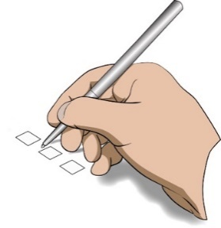

These are the things to do before travelling to New Zealand:
check that your passport is up to date
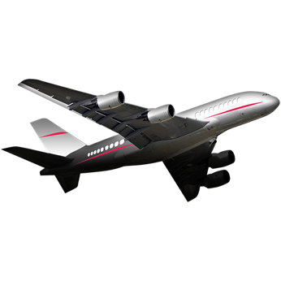
apply for a visa or NZeTA if you need one
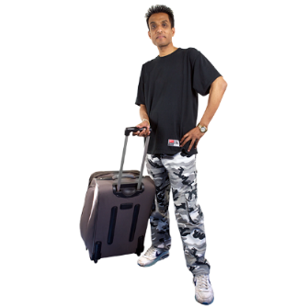
book your flight
check what you can bring into New Zealand
submit your NZTD

How to contact us
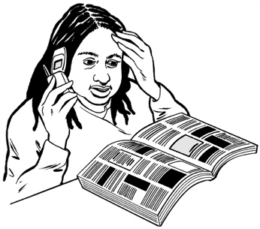
If you have any questions about the New Zealand Traveller Declaration you can phone us.
Our contact centre is open 24 hours a day 7 days a week.
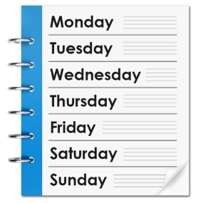
This means it is always open.

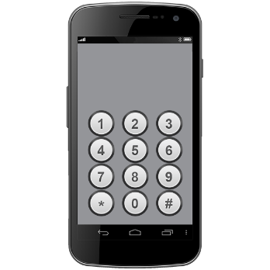
In New Zealand you can phone:
0800 359 269

This number is free to call if you are in New Zealand.

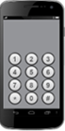
If you are calling from Australia you can phone:

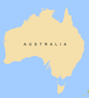
1800 359 269

This number is free to call if you are in Australia.

If you are calling from any other country you can phone:

+64 4 931 5799

You may be charged money for these calls
You can also send an online message to this website:

travellerdeclaration.govt.nz/contact
We will try to answer within 12 hours.
This information has been written by
Te Kāwanatanga o Aotearoa –
New Zealand Government

It has been translated into Easy Read by the Make it Easy Kia Māmā Mai service of People First New Zealand Ngā Tāngata Tuatahi.

The ideas in this document are not the ideas of People First New Zealand Ngā Tāngata Tuatahi.

Make it Easy uses images from:

- Changepeople.org

- Photosymbols.com

- SGC Image Works
- Huriana Kopeke-Te Aho
- T. Wood.
All images used in this Easy Read document are subject to copyright rules and cannot be used without permission.

